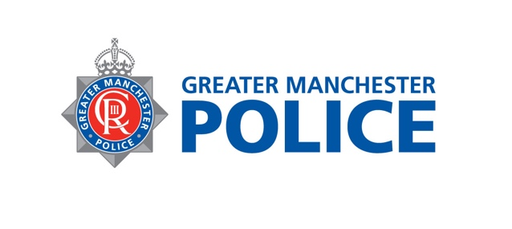

Health information following sexual violence

Forensic Medical Examination
If you've reported the assault to the police, they may discuss the option of a forensic examination at a Sexual Assault Referral Centre (SARC) — either Saint Mary’s in Manchester or SAFE Place in Liverpool.
You can still access SARC services without involving the police. Please call SARC for advice, as they are not a drop-in service and appointments are required to ensure the right staff are available.
During a forensic medical examination (lasting around 2–3 hours), they may:
- Take details about your health and the assault.
- Check for and record any injuries.
- Collect DNA evidence (for use now or later)
- Provide emergency contraception or infection prevention.
- Offer referrals for safety and support.
HIV and PEP (Post-Exposure Prophylaxis)
- HIV can be passed on through unprotected sex, but only if the other person has the virus.
- PEP is a 28-day course of medication that may prevent HIV after possible exposure.
- It must be started within 72 hours (3 days) — the sooner, the better.
- Not everyone will need PEP, as some situations carry lower risk.
- If you're worried about HIV after a sexual assault and can't attend a SARC within 72 hours or not attending SARC, please go to A&E or a sexual health clinic as soon as possible.
Hepatitis B Risk
- Hepatitis B can be passed on through unprotected sex, but only if the other person has the virus.
- A course of injections can help prevent infection — the first dose should be given within 7 days.
- If you’re concerned and not attending a SARC, please visit A&E or a sexual health clinic as soon as possible.
Other Sexually transmitted infections
- STIs like chlamydia and gonorrhoea can be passed on through unprotected sex.
- Visit your GP or sexual health clinic 2 weeks after the incident for testing.
- Blood tests for HIV, hepatitis, and syphilis may be offered between 6–12 weeks.
- If you attend a SARC, you may be given a home testing kit.
- Use condoms with new partners until you’ve had the all-clear.
Could you be at risk during pregnancy?
- If you’re not using contraception or have missed doses, there may be a risk of pregnancy after unprotected sex.
- Emergency contraception can help prevent pregnancy and works best when taken as soon as possible.
- Options include pills (effective up to 5 days) and the emergency coil (may work beyond 5 days).
- Speak to a healthcare professional promptly for advice.
- If you’re not attending a SARC, visit your GP, sexual health clinic, walk-in centre, or pharmacy.
Support after a sexual assault
- Support is available whether or not you report to the police.
- An ISVA (Independent Sexual Violence Adviser) can support you through the justice process.
- You may also want to speak with a counsellor.
- In Greater Manchester: Saint Mary’s Centre, Manchester Rape Crisis (women),
- We Are Survivors (men)
- In Merseyside: RASA
- In Cheshire: RASASC
Useful contact numbers
( | 0161 276 6515 (Saint Mary’s Centre)  0151 295 3550 (SAFE Place Merseyside)  0161 236 2182 (We are Survivors)  0330 363 0063 (Cheshire RASASC)
* | Mft.admin.secure@nhs.net  mft.safeplace.secure@nhs.net
: | St Mary's Centre:: Home (stmaryscentre.org)

