

Ethnicity Pay Gap Report and Action Plan

March 2025

The ethnicity pay gap, is different to equal pay, it shows the difference in the average hourly rate of pay between Black, Asian and Minority Ethnic employees, and White employees. This information is generally expressed as a percentage of average White employees’ earnings and calculated using the same calculation methodology as for gender pay gap reporting.

Gender pay gap reporting was made a statutory obligation for all organisations with more than 500 employees in 2016, with many organisations including Police Forces using this data to better understand and address issues with gender representation across their organisations. There is a strong argument that a similar approach can be taken in relation to Ethnicity Pay Gap (EPG) reporting, this is further supported by action 16 of the Inclusive Britain report which states:

Action 16
We will address the challenges with ethnicity pay gap reporting to support employers who want to demonstrate and drive greater fairness in the workplace.
BEIS will publish guidance to employers on voluntary ethnicity pay reporting in summer 2022. This guidance, which will include case studies of those companies who are already reporting, will give employers the tools to understand and tackle pay gaps within their organisations and build trust with employees.

The Department for Business, Energy and Industrial Strategy (BEIS) has conducted public consultation on ‘Ethnicity Pay Reporting’, for further detail here is the link - Ethnicity pay reporting: consultation (publishing.service.gov.uk).

In September 2021 CIPD published a helpful and supportive guide for employers wishing to adopt an EPG approach. Included in this are 6 clear principles and the recommendation is that Police Forces adopt these in EPG reporting.

The key elements are:
- Align ethnicity pay reporting with gender pay reporting but recognise the differences.
- Remember ethnicity representation is as important as, and strongly linked to, ethnicity pay gaps.
- Recognise the value of simplicity and clarity.
- Ensure the difference in pay terms & conditions for staff and officers is reflected in force EPG data.
- Focus on action – each force will publish their EPG action plan.
- Start and improve – the focus will be on closing any EPG identified.
- Combine comparability in data with tailoring of analysis and actions.

EPG reporting calculations need to be aligned to gender pay reporting for consistency purposes. The BEIS referred to alternative ways of utilising the data to support EPG reporting, it outlines three main options:

- One pay gap figure comparing average hourly earnings of ethnic minority employees as a percentage of white employees;
- Several pay gap figures comparing average hourly earnings of different groups of ethnic minority employees as a percentage of white employees;
- Ethnicity pay information by pay band or quartile, showing the proportion of employees from different ethnic groups by £20,000 pay bands or by pay quartiles.

Forces were asked to adopt a blended approach, utilising both options 2 & 3 and therefore providing ethnicity pay information across groups and by quartiles.

Forces are asked to adopt the minimum standard of publishing so there is a level of consistency and comparability in the data and information presented. It is understood the context and position of forces will be variable but for meaningful comparisons and assessments to be made it is important the same core information is available. Therefore, forces have been asked to provide a table of their minimum standards and publish this alongside a high-level action plan relating to the table contents. The action plan could be as simple as a list of actions the force is committed to completing.

In addition to the minimum standards to allow us to ensure the difference in pay terms & conditions for staff and officers is reflected in force EPG data and is inline with the key elements of the CIPD guidance; and to provide more clarity on our Ethnicity Pay Gaps we have also provided more details for the whole force and split between officers and staff.

Ethnicity recording for police personnel has been greatly improved as a request of the work done under the Police Uplift Programme, during which the National Standard for Recording Workforce Data Information was agreed.

The workforce data standard is a collaborative product developed by the College of Policing, NPCC and Operation Uplift. It was identified that a standardised collection of protected characteristics information was needed and it was agreed to be used as the standard for data collection in October 2020. The introduction of the standard has enabled progress and data improvements for workforce data. It is therefore essential that EPG reporting is based upon the standards and reporting categories outlined. The following outline of the ethnicity codes reflects the Workforce Recording Data Standard and has been adopted for the purposes of our EPG. Any disaggregated information has been aggregated into the five categories outlined:

White (Subheading - not an option for selection)
- English/Welsh/Scottish/Northern Irish/British
- Irish
- Gypsy or Irish Traveller
- Roma
- Any other White background, please describe

Mixed/Multiple ethnic groups (Subheading - not an option for selection)
- White and Black Caribbean
- White and Black African
- White and Asian
- Any other Mixed/Multiple ethnic background, please describe

Asian/Asian British (Subheading - not an option for selection)
- Indian
- Pakistani
- Bangladeshi
- Chinese
- Any other Asian background, please describe

Black/African/Caribbean/Black British (Subheading - not option for selection
- African
- Caribbean
- Any other Black/African/Caribbean background, please describe

Other ethnic group (Subheading - not an option for selection)
- Arab
- Any other ethnic group, please describe

Prefer not to say (Subheading for consistency only)
- Prefer not to say (includes not recorded or disclosed)

Ethnicity Pay Gap – Minimum Standards Publication Tables
The Pay Gap and Difference in the minimum standards publication table above and based on the particular group versus the total of all the other groups (not including those not recorded/disclosed), for example:
Asian Group versus the total of all the other groups (not including those not recorded/disclosed)
More detailed pay gaps and differences can be found below under the individual sections for the Whole Workforce, Police Officer and Police Staff data.

Whole Force Ethnicity Pay Gap Data

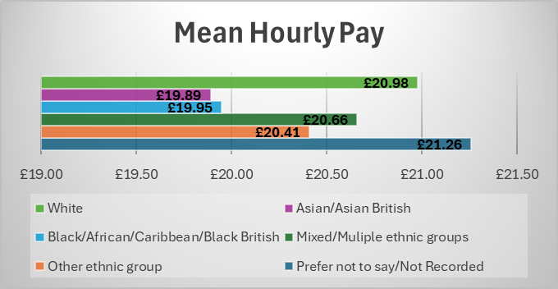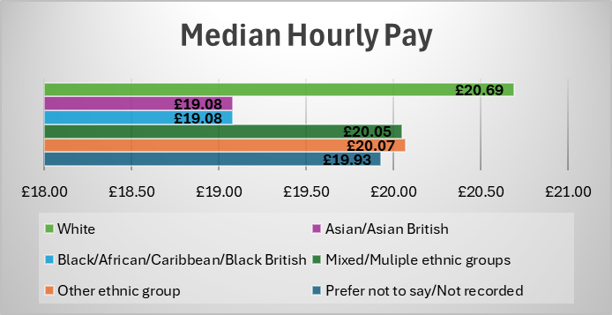

Total Force Bonus Payments
Based on the total force relevant employees = 12,607 of which 1399 received a Bonus Payment
(less 11 whose ethnicity isn’t recorded)

 | White | Minority Ethnic | Gap/Difference
Total Paid a Bonus Payment | 1247 | 141 | 1106
Percentage of Force Paid a Bonus Payment | 11.01% | 1.12% | 9.89%
Percentage of total bonus payments made | 99.21% | 10.08% | 89.13%
Mean Bonus Payment | £166.37 | £172.90 | -0.04%
Median Bonus Payment | £100.00 | £100.00 | 0.0%

Whole Force Comparison of Data – based on NPCC Minimum Standards Publication Table
Mean Hourly Pay

Median Hourly Pay

Whole Force Ethnicity Pay Gap – Quartile Split
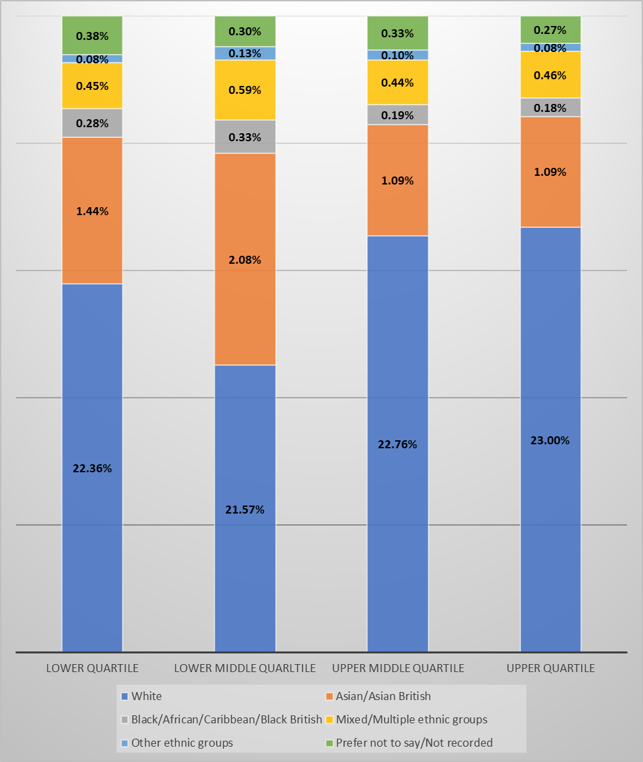

Police Officer Ethnicity Pay Gap Data

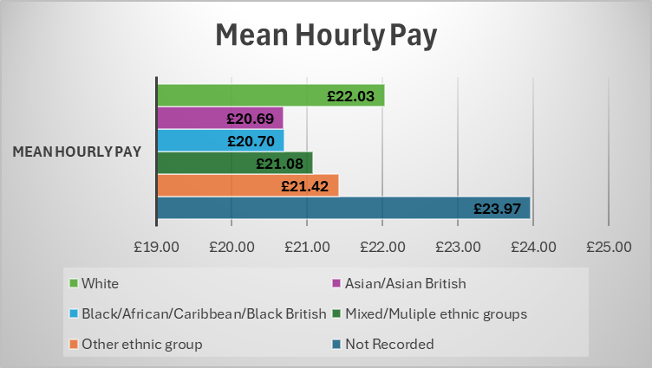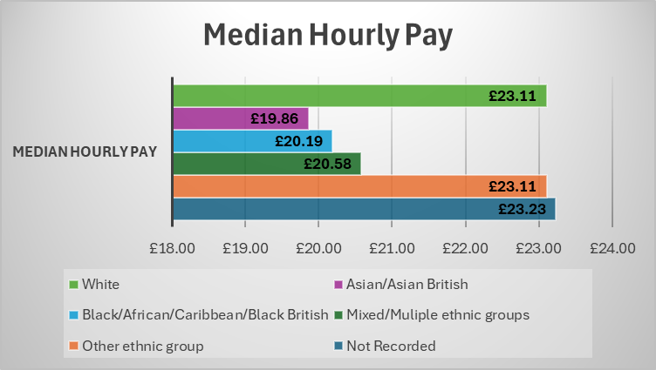

Police Officer Bonus Payments
Based on the total officer relevant employees = 7927 of which 1115 received a Bonus Payment
(less 4 whose ethnicity isn’t recorded)

 | White | Minority Ethnic | Gap/Difference
Total Paid a Bonus Payment | 988 | 127 | 861
Percentage of Force Paid a Bonus Payment | 12.39% | 1.6% | 10.79%
Percentage of total bonus payments made | 88.29% | 11.35% | 76.94%
Mean Bonus Payment | £179.03 | £174.14 | -0.03%
Median Bonus Payment | £100.00 | £100.00 | 0.00%

Police Officer Comparison of Data – based on NPCC Minimum Standards Publication Table
Mean Hourly Pay

Median Hourly Pay

Police Officer Ethnicity Pay Gap – Quartile Split
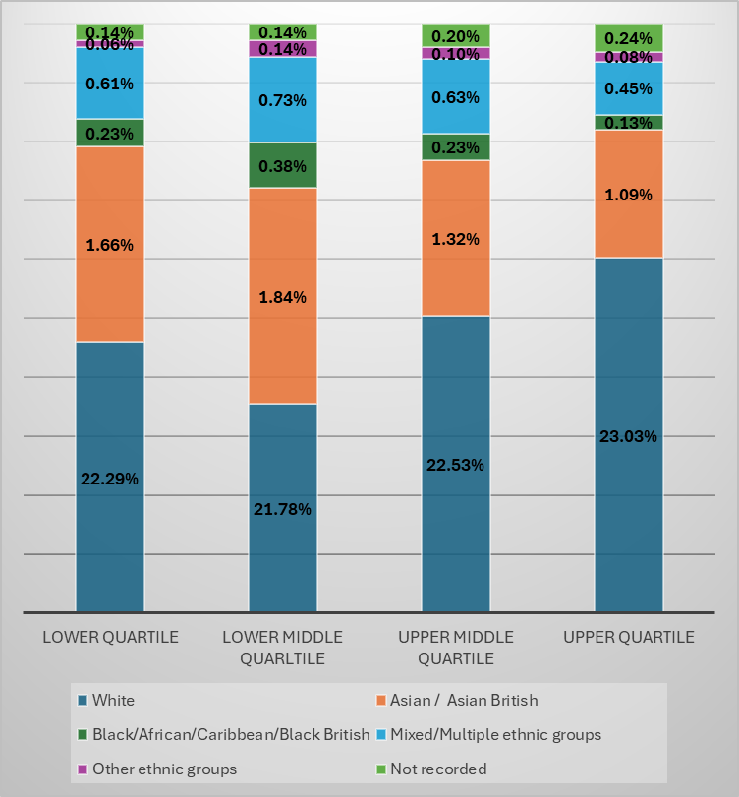

Police Staff Ethnicity Pay Gap

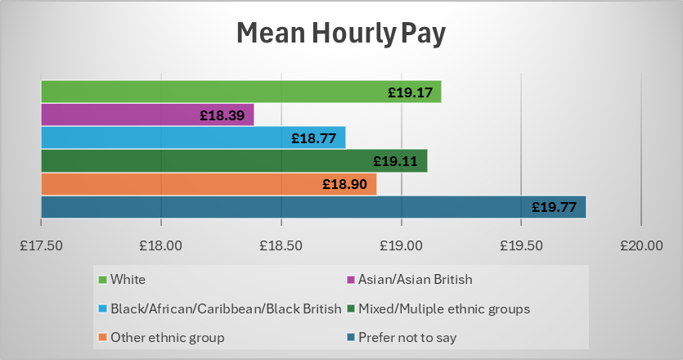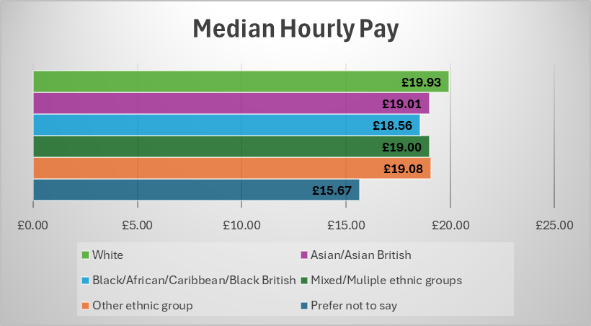

Police Staff Bonus Payments
Based on the total staff relevant employees = 4,635 of which 280 received a Bonus Payment
(less 7 whose ethnicity isn’t recorded)

 | White | Minority Ethnic | Gap/Difference
Total Paid a Bonus Payment | 259 | 14 | 245
Percentage of Force Paid a Bonus Payment | 5.59% | 0.3% | 5.29%
Percentage of total bonus payments made | 92.50% | 5% | 87.5%
Mean Bonus Payment | £118.09 | £122.91 | -£4.82
Median Bonus Payment | £100.00 | £100.00 | £0.00

Police Staff Comparison of Data – based on NPCC Minimum Standards Publication Table
Mean Hourly Pay

Median Hourly Pay

Police Staff Ethnicity Pay Gap – Split of Quartiles

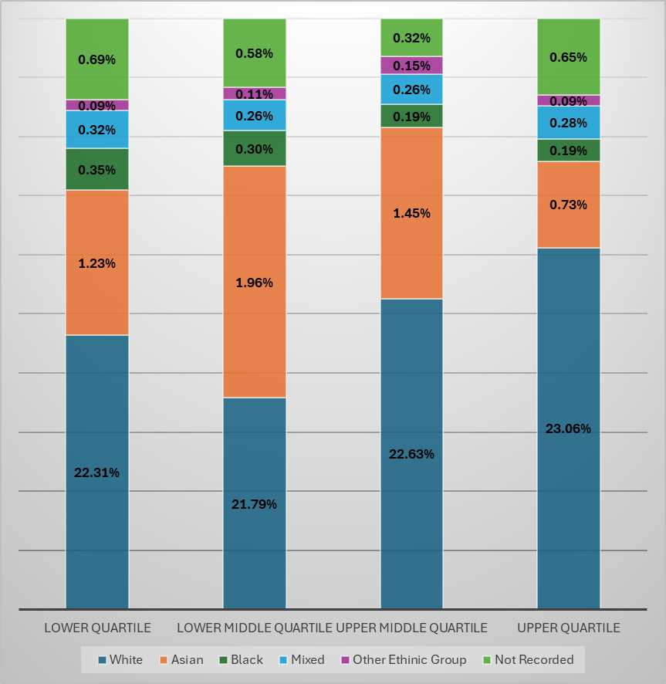


Ethnicity Pay Gap Action Plan
Our Culture and Inclusion Strategy includes nine objectives. Five of these are internal objectives. The purpose of these objectives are :
to make GMP an inclusive, equitable, representative workplace where staff feel valued and that they belong, have a voice and will be supported to be the best they can be, enabling them to deliver an excellent service to the public.
This action plan considers these objectives, and the actions assigned, that will help to address our Gender Pay Gaps.
Governance, oversight and monitoring of the Action Plan will be undertaken via GMP’s Culture and Inclusion Board and The Strategic Resourcing and People Board.

